Exercise Section I
(DC circuits analysis)

1. For the circuit of Fig.1 find the currents, in microamperes, if the powers absorbed are :
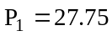 nW, 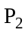 = 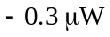, and 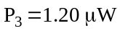.
Ans. 18.5, –200 , 800

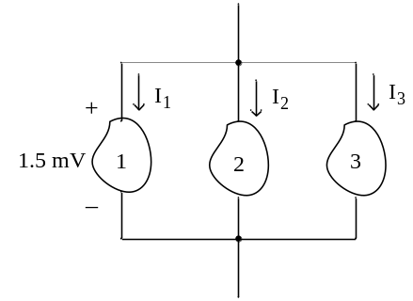
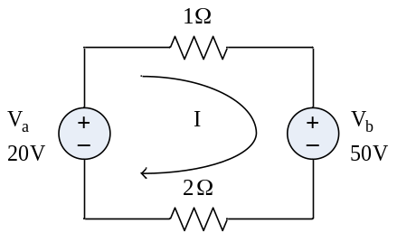

Fig.1 Fig.2

2. Find the power delivered by the sources in the circuit of Fig.2
Ans. 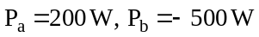

3. Find voltages V₁, V₂, and V₃ in Fig.3, given that the generalized circuit elements have
absorbed powers P₁ = 250 W, P₂ = –125 W, and P₃ = 100 W
Ans. 50 V, –25 V, –20 V
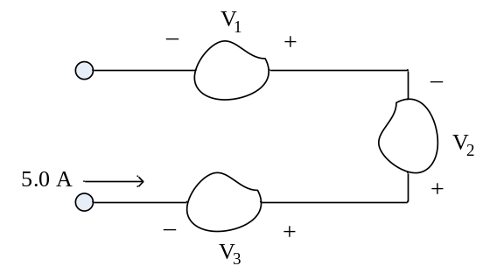
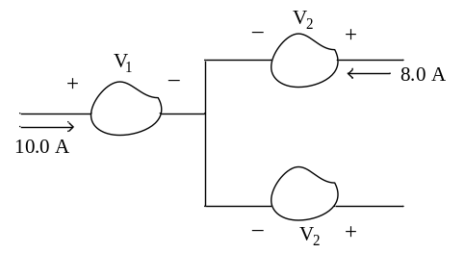
Fig.3 Fig.4

4. In the circuit shown in fig.4 , V₁ = 20 V and V₂ = V₃ = 15 V. What is the total power
absorbed in the three circuit elements ?
Ans. 50 W

5. Three resisters are in series and have a total constant voltage V_{T}. R₁ has a voltage of 20 V,
R₂ has a power of 25 W, and R₃ = 2 Ω. If the constant current is 5 A, find V_{T}
Ans. 35 V

6. In the circuit shown Fig.5 , find the power absorbed by the 5 V battery.
Ans. – 5 W

7. For the ladder network shown in Fig.6, find the source voltage 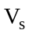 which results in a
current of 7.5 mA in the 3 - Ω resister.
Ans. 0.705 V

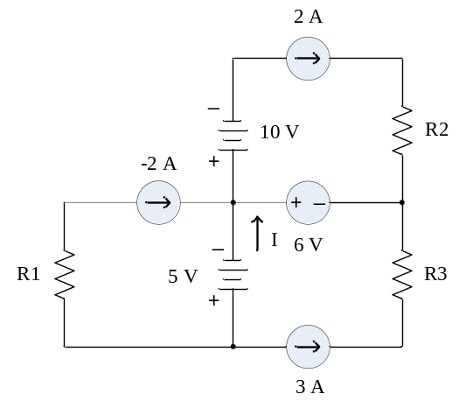 Fig.6
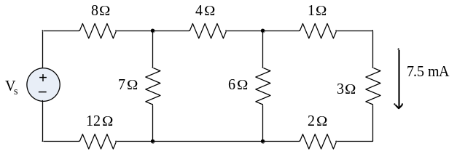
Fig.5

8. The network shown in Fig. 7, obtain the currents in all the network branches.

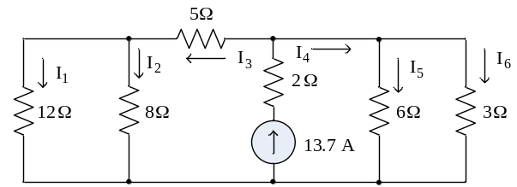

Fig.7

Ans. 0.93, 1.39, 2.32, 11.38, 3.79, 7.59 A

9. Obtain the current in each resistor in Fig. 8 , using network reduction methods.

Ans. I_{A} = 1.67, I_{B} = 3.33, I_{C} = 2.50, I_{D} = 1.25, I_{E} = 1.25, I_{F} = 2.50 A

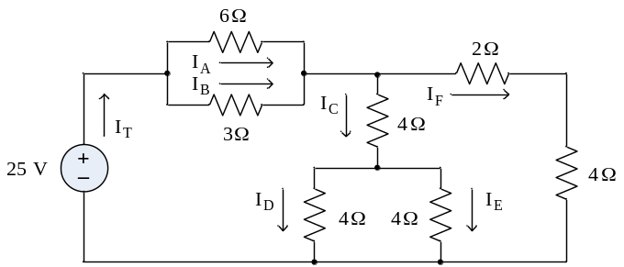

Fig.8

10. Obtain the current 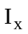 in the 10-Ω resister in Fig.9, using superposition.
Ans. –1 A.
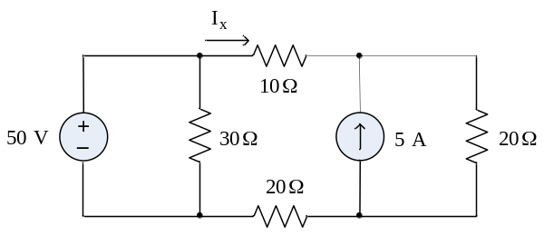
Fig.9
11. Replace the active network to the left of terminal AB in Fig.10 by a thevenin equivalent.
Ans. R_{TH} = 50 Ω , V_{TH} = 80 V

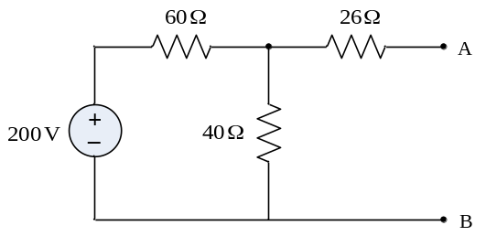
Fig.10

12. Obtain the Norton equivalent for the active network of Problem 11.
Ans. R_{TH} = 50 Ω , I_{N} = 1.60 A

13. For the network shown in Fig.11, obtain the mesh currents ,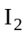and 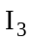

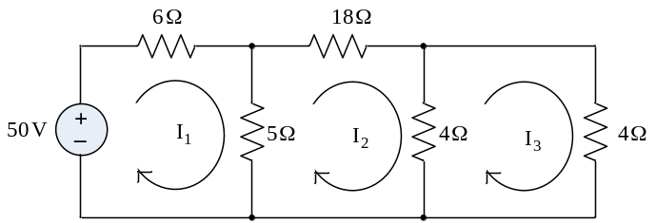

Fig.11
Ans. 5.0, 1.0, 0.5 A

14. Loop currents are shown in the network of Fig.12. Write the matrix equation and solve
for ,and
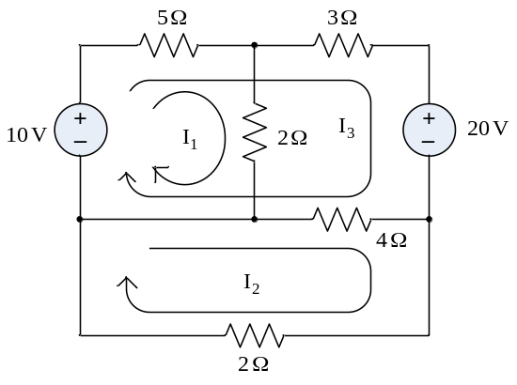
Fig.12
Ans. 3.55, –1.98, –2.98 A

15. The network of Problem 14 has been redrawn in Fig.13 for solution by the node voltage
method. Find the node voltages V₁ and V₂ , and with then verify the three currents
obtained in Problem 14.
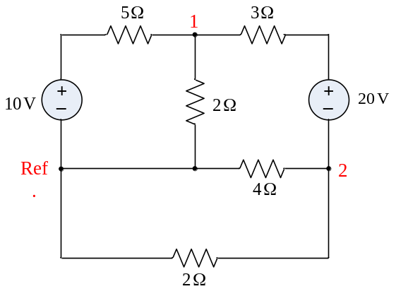
Fig.13
Ans. 7.11, –3.96 V

16. Obtain the four mesh currents in Fig.14

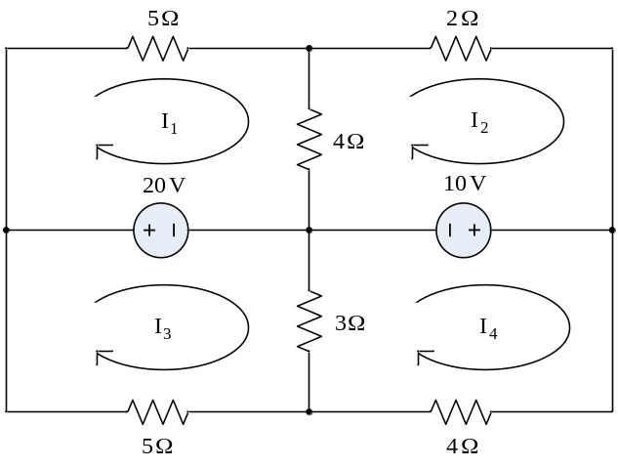
Fig.14
Ans. 2.11, – 0.263, – 0.34, 0.426 A

17. Find the node voltages V₁, V₂, V₃, and V₄

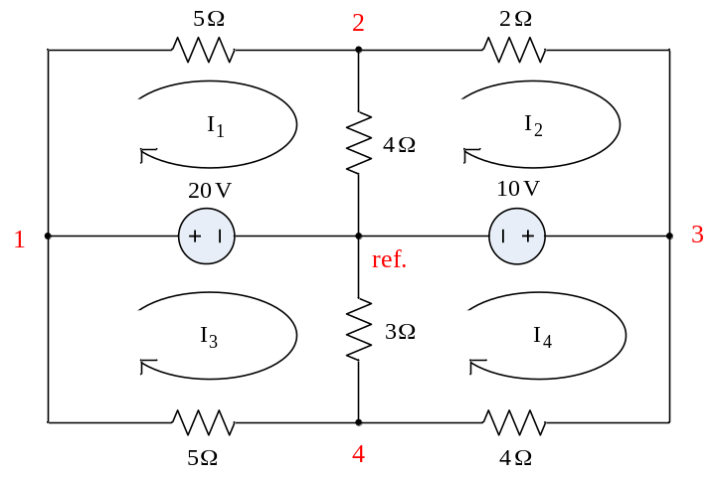
Fig.15
Ans. 20, 9.47, 10, 8.30 V

